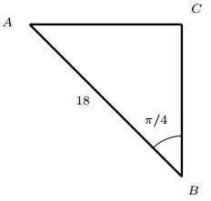Find the length of AC. Give your answer in exact form.

9√2

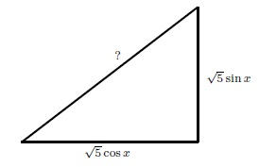 Find the length of the hypotenuse in the right triangle below where x is a real number.
√5

Find the area of a square whose diagonal is 40 metres
800 m^2

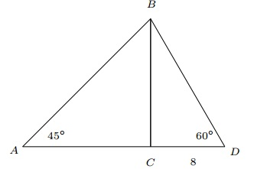 In the figure below BC is perpendicular to AD, CD = 8, the measure of angle D is 60° and the measure of angle A is 45°. Find the length of AB
8√6

